# PRESS RELEASE

## FOR IMMEDIATE RELEASE: March 19, 2025 CONTACT: Mary Jo Foley, Director of Outreach

**Society for Range Management**

**srmoutreach@rangelands.org**

**P: 303-986-3309**

**Simonds Honored by Society for Range Management with Sustained Lifetime Achievement Award**

SPOKANE, WASHINGTON– Gregg Simonds received the ***Sustained Lifetime Achievement Award*** at the Society for Range Management’s 78th Annual Meeting in Spokane, Washington last month.  The Sustained Lifetime Achievement Award is presented by the Society for Range Management to members for long-term contributions to the art and science of range management and to the Society for Range Management (SRM).

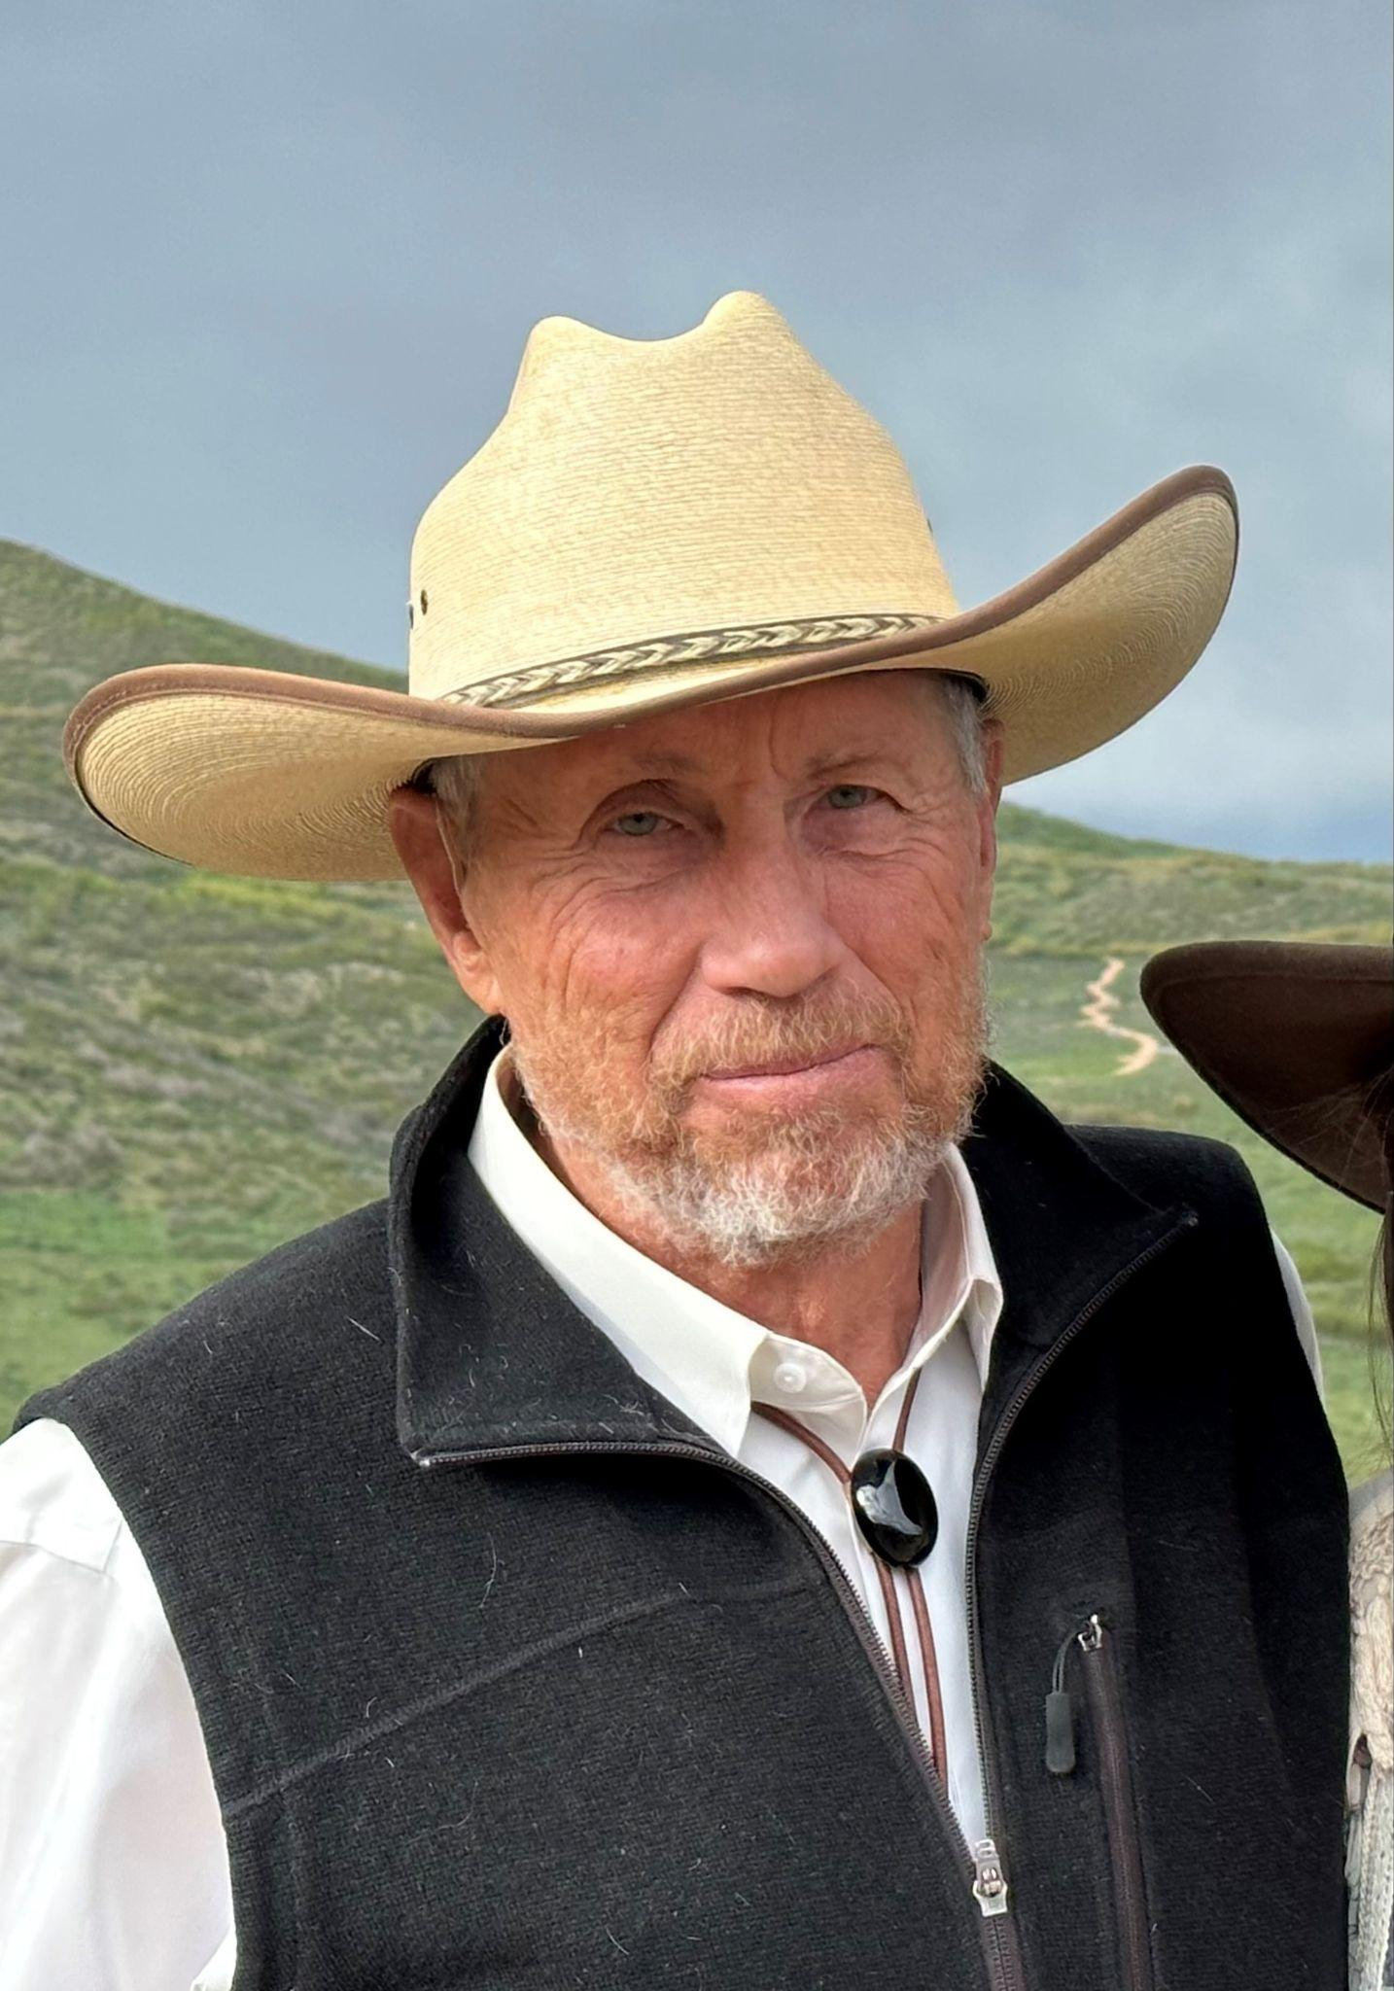Simonds grew up in a small town in Southern Idaho, where his passion for the natural world was sparked through hunting. His academic journey began humbly with a 1.0 GPA at a local community college, but after transferring to Utah State University, he found his calling in natural resource management. Inspired by Dr. Thad Box’s teachings on responsible land stewardship, he developed a personal mission: “To be a positive resource management example by making money while improving the land.”

Early in his career, Gregg secured a consulting contract to improve a private ranch, demonstrating that profitability and land stewardship could go hand in hand. His success led to further consulting opportunities, with ranching clients even supporting his graduate studies. By age 29, he became the manager of Deseret Land and Livestock, where he revolutionized grazing management by focusing on timing rather than stocking rates. This approach reduced hay feeding, increased wildlife diversity, and gained national recognition, earning the prestigious “Take Pride in America Award.” Later, at Humboldt Ranch in Nevada, Gregg applied his expertise to restore over 100 miles of riparian habitats, demonstrating that sustainable grazing could transform degraded landscapes. His work is highlighted in *The Humboldt Ranch: Changing a Landscape to a Lifescape,* showcasing the impact of thoughtful land stewardship.

Today, Gregg continues to be a leader in rangeland management, sharing his knowledge with landowners, agencies, and conservation groups. His lifelong dedication to balancing economic success with ecological stewardship has set a standard for sustainable ranching, leaving a lasting impact on both private and public lands.

For the tremendous contributions to the science and management of rangeland ecosystems he has made, it is with great honor the Society of Range Management recognized Gregg Simonds with the Sustained Lifetime Achievement Award.