# PRESS RELEASE

## FOR IMMEDIATE RELEASE: March 19, 2025 CONTACT: Mary Jo Foley, Director of Outreach

**Society for Range Management**

**srmoutreach@rangelands.org**

**P: 303-986-3309**

**Schultz Honored by Society for Range Management with Sustained Lifetime Achievement Award**

SPOKANE, WASHINGTON – Brad Schultz received the ***Sustained Lifetime Achievement Award*** at the Society for Range Management’s 78th Annual Meeting in Spokane, Washington last month.  The Sustained Lifetime Achievement Award is presented by the Society for Range Management to members for long-term contributions to the art and science of range management and to the Society for Range Management (SRM).

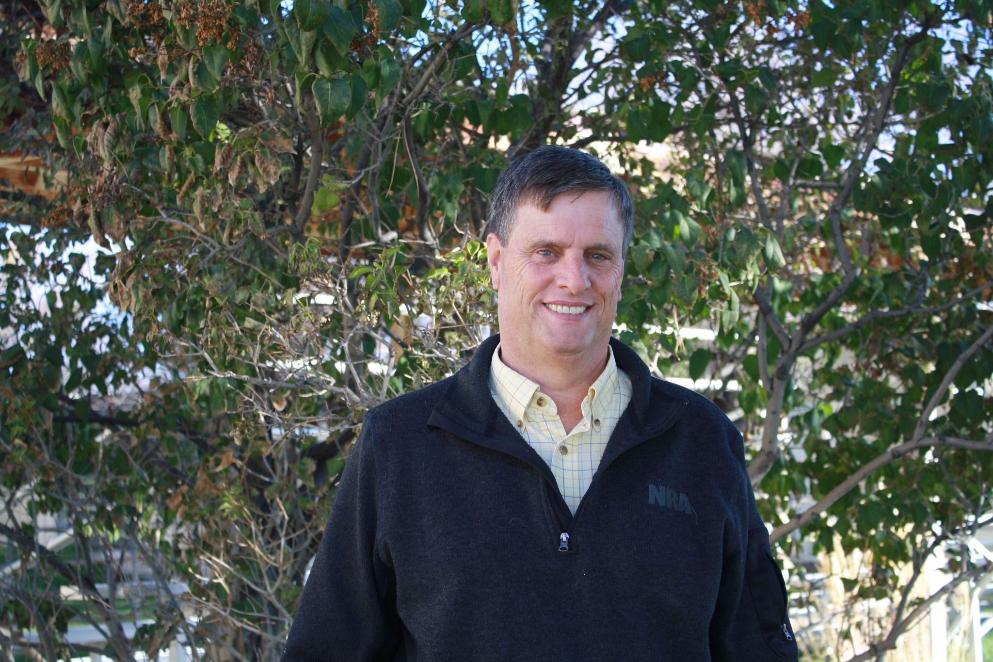Brad Schultz has been a dedicated member of the Society for Range Management since 1979, committing 45 years to Rangeland Ecology and Management. His career has spanned various challenges, including shifting priorities, legislation, and land use controversies, yet he has remained steadfast in providing science-based solutions. His expertise in invasive weeds, sage grouse conservation, alternative management strategies, and repeat photography studies has significantly influenced rangeland management practices.

Recognized as one of the foremost rangeland ecologists, Brad has played a crucial role in helping government officials, wildlife policy experts, and federal agencies navigate complex rangeland issues. His extensive experience in the Great Basin and northern Mojave Desert has positioned him as a key figure in shaping land management policies. He has contributed his expertise to numerous NEPA documents, ensuring informed decision-making for multiple government agencies and departments. Beyond his work in the U.S., Brad has educated and trained land managers, researchers, and policymakers in 7 countries across 2 continents. With 13 international trips, he has shared his knowledge of range management, natural resource conservation, vegetation monitoring, plant ecology, and noxious weed control. His ability to translate scientific research into practical applications has made a lasting impact on global rangeland management.

Brad’s contributions to the field are reflected in his extensive body of work, including 29 peer-reviewed journal articles, 94 Extension publications, 18 proceedings papers, 53 trade journal articles, and over 60 NEPA documents. He has also given more than 145 presentations at state, regional, and national conferences. His dedication, expertise, and passion for rangeland conservation have rightfully earned him the Society for Range Management Sustained Lifetime Achievement Award.

For the tremendous contributions to the science and management of rangeland ecosystems he has made, it is with great honor the Society of Range Management recognized Brad Shultz with the Sustained Lifetime Achievement Award.