# PRESS RELEASE

## FOR IMMEDIATE RELEASE: March 19, 2025 CONTACT: Mary Jo Foley, Director of Outreach

**Society for Range Management**

**srmoutreach@rangelands.org**

**P: 303-986-3309**

**Schantz Honored by Society for Range Management with Outstanding Young Professional Award**

SPOKANE, WASHINGTON – Merilynn Schantz received the ***Outstanding Young Professional Award*** at the Society for Range Management’s 78th Annual Meeting in Spokane, Washington last month. The Award is presented by the Society to an individual member or couple who have demonstrated extraordinary potential and promise as range management professionals. This award is presented as an encouragement for outstanding performance by young men and women entering the profession of range management.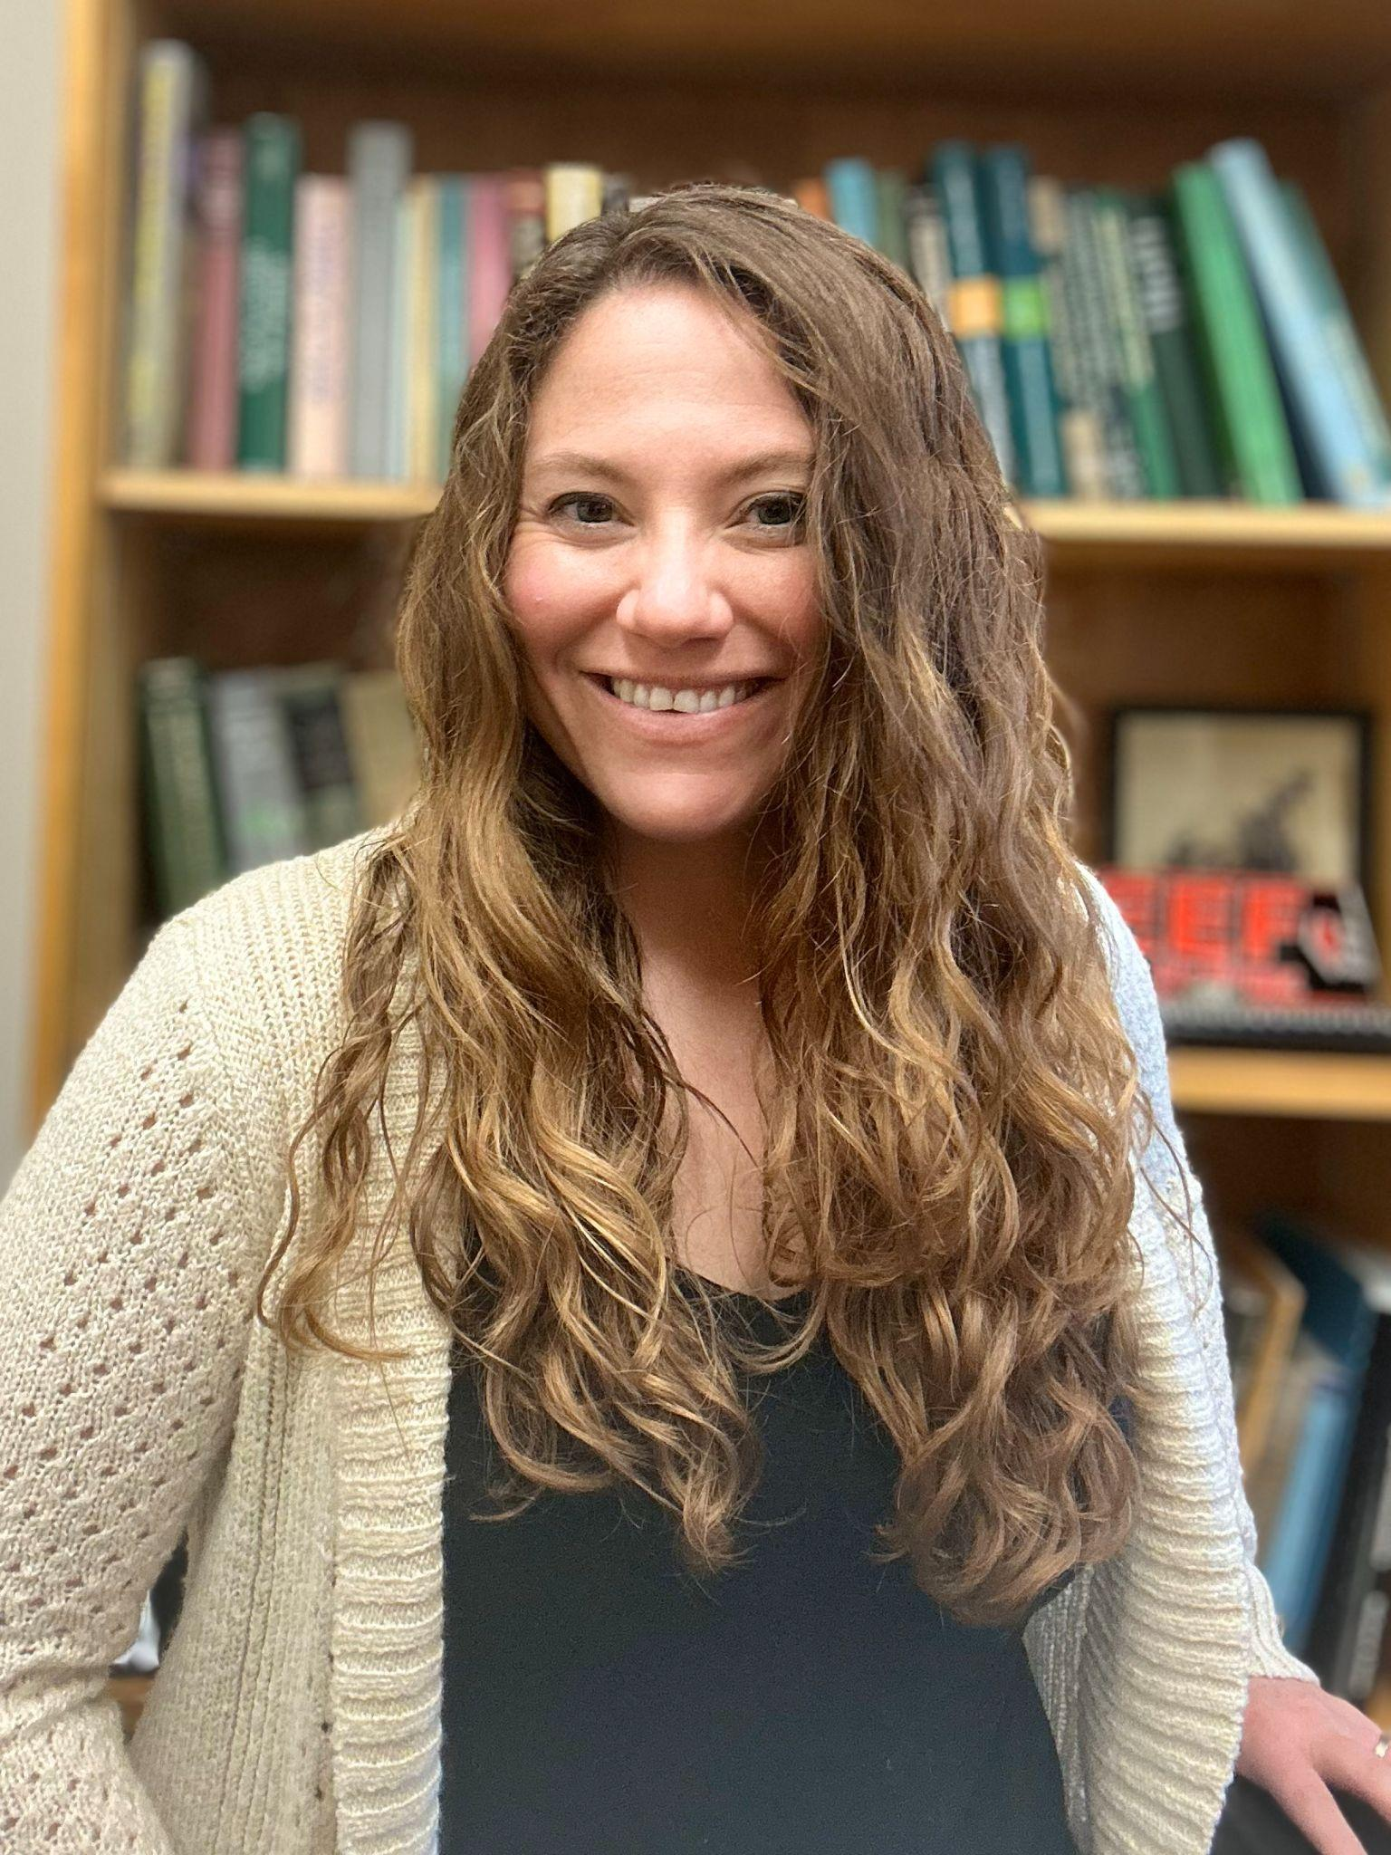

Dr. Merilynn Schantz is a Research Rangeland Scientist at the USDA-ARS Grassland, Soil, and Water Research Station in Temple, Texas, where her work advances the science and management of rangeland and pastureland ecosystems. Her research focuses on the interactions between climate, soil nutrients, and restoration seeding to improve livestock forage availability, plant structure, and ecological succession. She is currently developing climate and plant production forecasting tools, studying large-scale grazing strategies to enhance soil and plant health, and assessing the benefits of grazed cover crops for animal nutrition and ecosystem sustainability.

In addition to her research, Dr. Schantz plays an active role in the scientific community. She serves as the Managing Editor for *Rangeland Ecology and Management*, the leading journal of the Society for Range Management, and is a member of multiple professional societies, including the Society for Range Management, the Soil Water Conservation Society, and the Soil Science Society of America. Her leadership extends to several committees and working groups that support advancements in rangeland and soil science.

Dr. Schantz is also a key contributor to the USDA’s Long-Term Agroecosystem Research (LTAR) network, where she leads the Weather and Climate working group. In this role, she collaborates with top scientists to improve the quality and accessibility of climate data for agricultural and natural resource management. Through her dedication to research, leadership, and collaboration, Dr. Schantz continues to make a significant impact on rangeland sustainability and ecosystem resilience.

For the tremendous contributions to the science and management of rangeland ecosystems he has made, it is with great honor the Society of Range Management recognized Merilynn Schantz with the Outstanding Young Professional Award.