# PRESS RELEASE

## FOR IMMEDIATE RELEASE: March 19, 2025 CONTACT: Mary Jo Foley, Director of Outreach

**Society for Range Management**

**srmoutreach@rangelands.org**

**P: 303-986-3309**

**Santos Honored by Society for Range Management with W.R. Chapline Award**

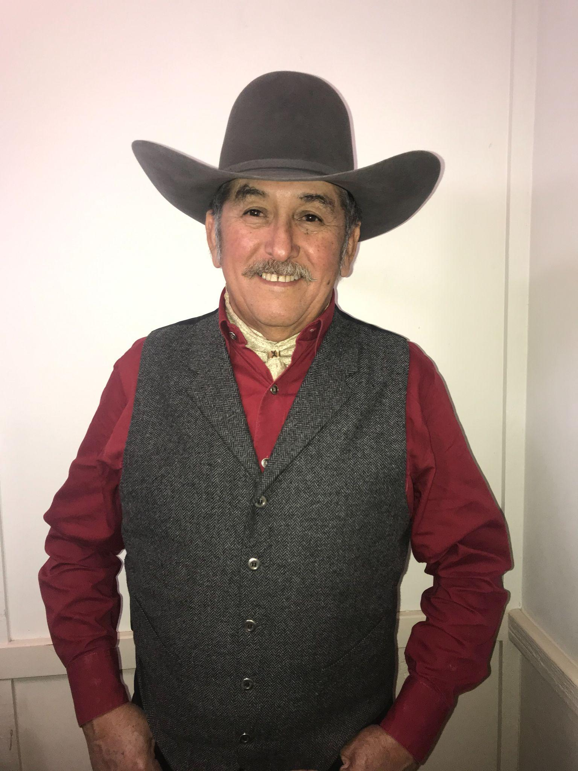SPOKANE, WASHINGTON – Jose Alfonso Ortega-Santos received the ***W.R. Chapline Land Stewardship Award*** at the Society for Range Management’s 78th Annual Meeting in Spokane, Washington last month. The W. R. Chapline Land Stewardship Award gives special recognition to members of the Society for exceptional accomplishments and contributions in the application of the art and science of range management. It is given in recognition of exceptional landowners, land managers, administrators and counselors in the field of range management and supporting disciplines.

Dr. Ortega is a distinguished range scientist with a Ph.D. in Agronomy with an emphasis on grazing management from the University of Florida. Early in his career, he served as Director of the Livestock Divison Northeast Region and later as the National Leader of the Forages and Grasslands Program.

“Poncho” has spent a lifetime dedicated to rangeland science, beginning with his early work in Mexico and continuing through his tenure at Texas A&M University-Kingsville. From leading the Livestock Division and National Forages and Grasslands Program at INIFAP to mentoring over 20 graduate students, his impact has been profound. His expertise in cattle-wildlife interactions and habitat management has shaped research and practical applications across North and South America.

He is a true leader in SRM, always ensuring that rangeland science has a seat at the table in critical industry discussions. Serving as President of both the Texas Section and Parent Society, he has strengthened SRM’s influence and advanced sustainable range management. His contributions, including over 140 publications and multiple books, have guided land stewards, ranchers, and fellow researchers alike.

Now residing in South Texas with his wife Caty, Dr. Ortega continues to be a trusted voice in rangeland science. His consulting work with iconic ranches like the King Ranch Corporation and EI Sauz Ranch underscores his ability to bridge science and real-world land management.

For the tremendous contributions to the science and management of rangeland ecosystems he has made, it is with great honor the Society of Range Management recognized Jose Alfonso Ortega-Santos with the W.R. Chapline Land Stewardship Award.