# PRESS RELEASE

## FOR IMMEDIATE RELEASE: March 19, 2025 CONTACT: Mary Jo Foley, Director of Outreach

**Society for Range Management**

**srmoutreach@rangelands.org**

**P: 303-986-3309**

**Roath Honored by Society for Range Management with Renner Award**

SPOKANE, WASHINGTON 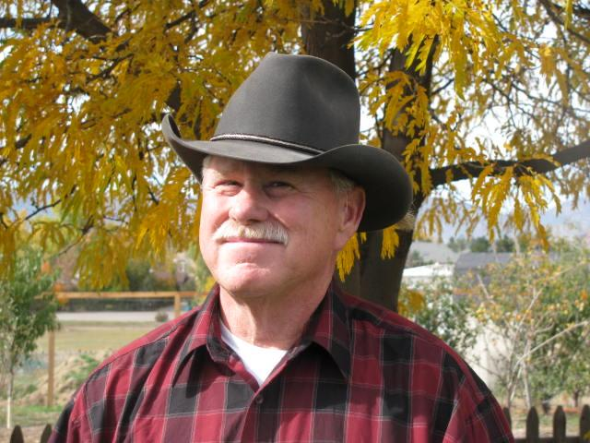– Dr. Roy L. Roath, a 50-year member and leader in the Society for Range Management (SRM) and a true trail boss received the ***Frederic G. Renner Award*** at the Society for Range Management’s 78th Annual Meeting in Spokane, Washington last month.  The Renner Award isthe most prestigious award bestowed by the SRM and was made possible by a generous contribution from Frederic G. Renner, a Charter and Life member, and SRM’s second President (1949).  The award is presented with the belief that such recognition will foster better use of rangeland resources and a broader understanding of the contributions that these resources make to the welfare of all people.

Dr. Roath’s extensive contributions include pioneering research on cattle use patterns in riparian areas, grazing dynamics under different systems, and the development of adaptive grazing guidelines.

One of his greatest contributions has been the development of the Grazing Response Index (GRI). His expertise in rangeland ecology also extended to wildlife habitat management, serving as a technical advisor to state agencies and contributing to sage grouse conservation efforts across multiple states.

A seminal contributor to collaborative land management, Dr. Roath played a key role in habitat evaluation protocols, public-private land coordination, and conflict resolution efforts. His leadership within SRM is reflected in his service on the Board of Directors, committee leadership, and organization of key events such as the Bridging the Gap initiative.

He has been a committed member and leader in SRM for over 50 years, serving at section and international levels on committees, Board of Directors, co-chair of SRM’s 2010 Annual Meeting in Denver, Publicity Chair for the 2020 Annual Meeting, and organizer of the Society’s wildlife habitat committee. His contributions have been recognized through a multitude of awards, including the SRM Outstanding Achievement Award, the Chapline Stewardship Award, and now the Renner Award, honoring his exemplary career in range management and conservation.

For his tremendous contributions to the science and management of rangeland ecosystems, it is with great honor the Society of Range Management recognized Dr. Roy L. Roath with the Renner Award.