# PRESS RELEASE

## FOR IMMEDIATE RELEASE: March 19, 2025 CONTACT: Mary Jo Foley, Director of Outreach

**Society for Range Management**

**srmoutreach@rangelands.org**

**P: 303-986-3309**

**McMillan Honored by Society for Range Management with Outstanding Achievement Award**

SPOKANE, WASHINGTON – Lisa Clarke McMillan received the ***Outstanding Achievement in Land Stewardship Award*** at the Society for Range Management’s 78th Annual Meeting in Spokane, Washington last month. The Award is presented by the Society for Range Management for outstanding achievement to members and other qualified individuals and groups working with rangelands. 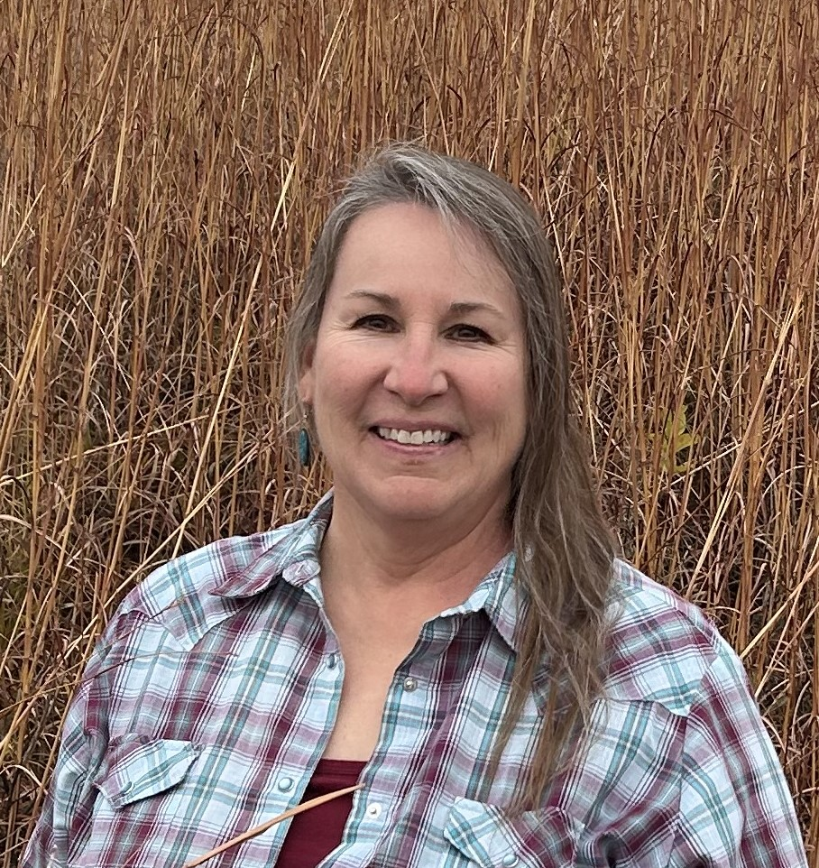

Lisa Clarke-McMillan is a highly respected leader in land stewardship and conservation, with over 30 years of experience in range management. Since earning her degree from the University of Nebraska-Lincoln in 1987, she has dedicated her career to promoting sustainable grazing and prescribed burning. As a Soil Conservationist with the USDA NRCS in Broken Bow, she has influenced landowners and conservation professionals across Nebraska, helping them implement effective land management practices.

A strong advocate for prescribed burning, Lisa played a key role in controlling the spread of eastern red cedar on her family ranch and helped establish Nebraska’s Prescribed Burn Task Force. Her leadership in developing the state’s Prescribed Burn Associations and shaping the NRCS Technical Service Provider program has been instrumental in educating and mentoring others in burn planning and implementation.

Beyond her work in land management, Lisa is committed to educating the next generation of range managers. She has been actively involved in the Nebraska SRM Range Youth Camp, Range Judging events, and the national High School Youth Forum Subcommittee, ensuring students have valuable learning opportunities. Known for her energy and dedication, Lisa has made a lasting impact on Nebraska’s rangelands and conservation community, making her a deserving recipient of SRM’s Outstanding Achievement Land Stewardship Award.

For the tremendous contributions to the science and management of rangeland ecosystems she has made, it is with great honor the Society of Range Management recognized Lisa Clarke McMillan with the Outstanding Achievement in Land Stewardship Award.