# PRESS RELEASE

## FOR IMMEDIATE RELEASE: March 19, 2025 CONTACT: Mary Jo Foley, Director of Outreach

**Society for Range Management**

**srmoutreach@rangelands.org**

**P: 303-986-3309**

**McCord Honored by Society for Range Management with Outstanding Achievement Award**

SPOKANE, WASHINGTON– Dr. Sarah McCord received the ***Outstanding Achievement in Research Award*** at the Society for Range Management’s 78th Annual Meeting in Spokane, Washington last month. The Award is presented by the Society for Range Management for outstanding achievement to members and other qualified individuals and groups working with rangelands. 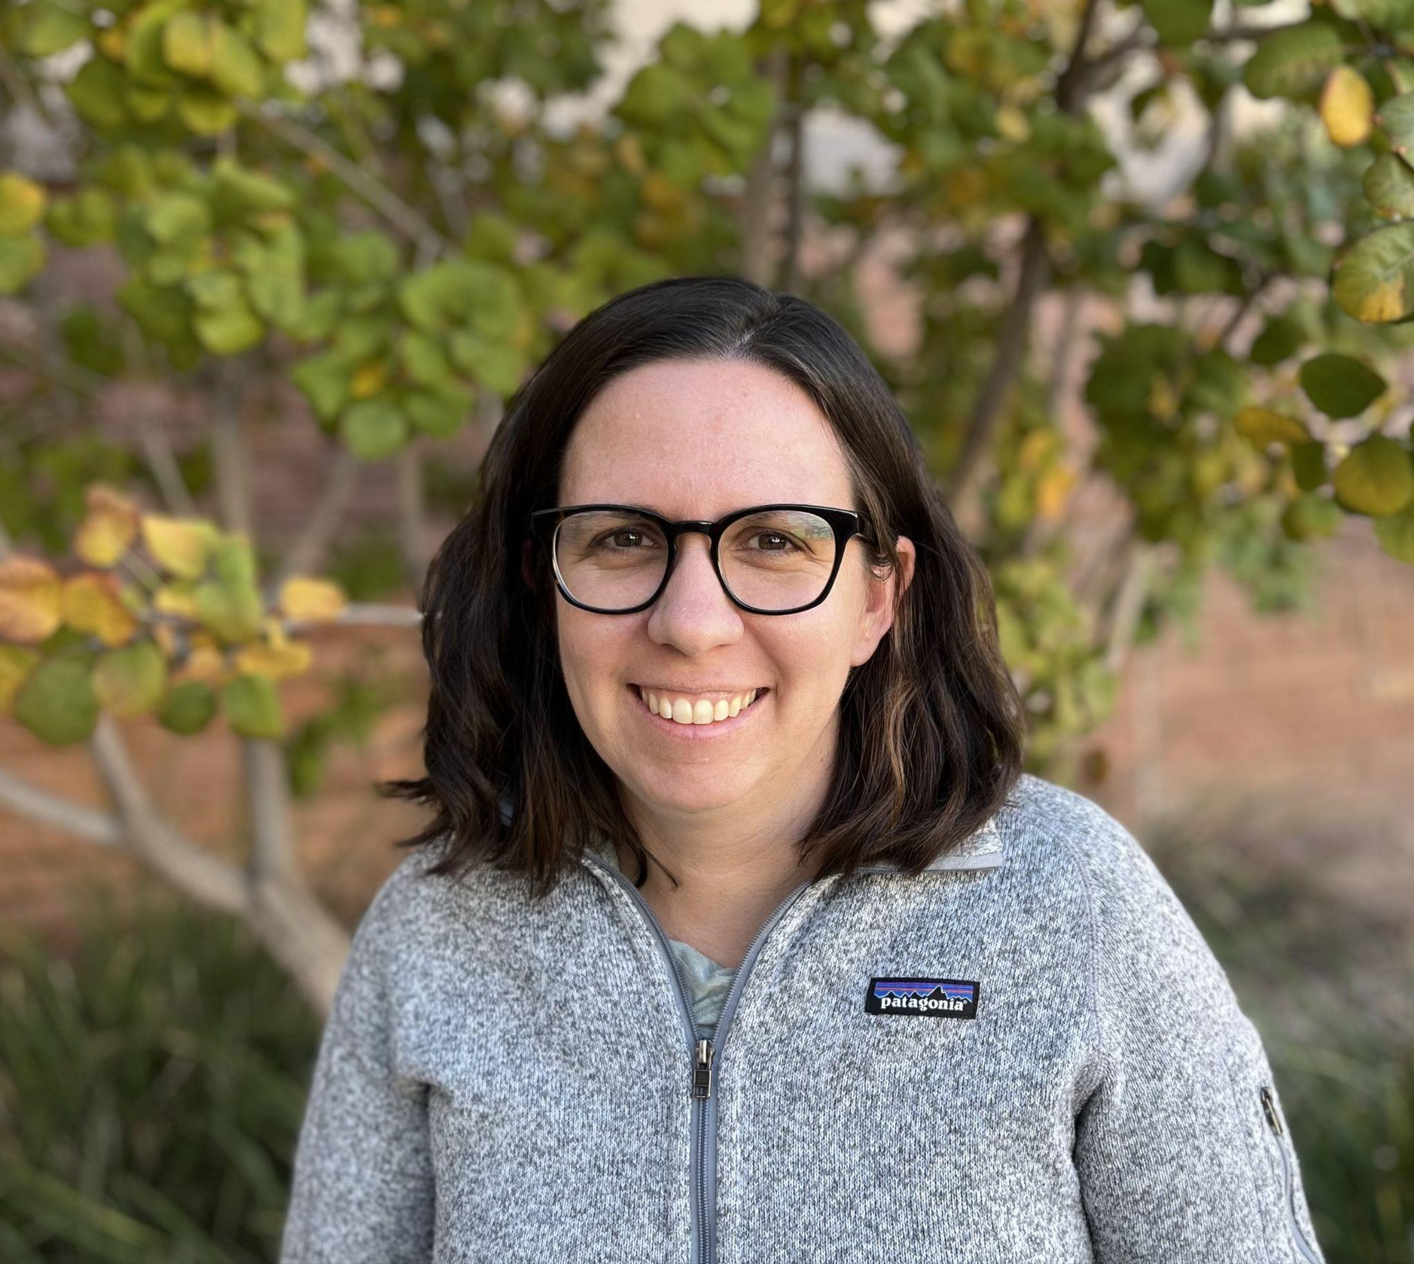

Dr. Sarah McCord has made a groundbreaking contribution to rangeland science with the creation of the Landscape Data Commons, a platform that unites multiple rangeland monitoring datasets while ensuring their quality. This innovative tool has expanded access to vital data, enabling researchers, land managers, and conservationists to better understand and interpret rangeland conditions. By standardizing monitoring data, Dr. McCord has laid the foundation for more effective analysis of key issues such as invasive species, soil erosion, wildlife habitat, and conservation efforts.

Her work has also made possible the development of fractional vegetation cover products, which use machine learning to estimate vegetation cover and production across all U.S. rangelands from 1986 to today. Without high-quality, standardized datasets, these advancements—linking ground and satellite data—would not exist. The ability to track vegetation changes over time is a game-changer for managing rangelands and guiding science-based decision-making.

Dr. McCord’s impact extends beyond data innovation; her leadership, collaboration, and mentorship have shaped the future of rangeland research. By bringing together diverse data providers and users, she has created a resource that will continue to inform conservation and land management for years to come. Her dedication to quality data and scientific progress has made an enduring mark on the rangeland community.

For the tremendous contributions to the science and management of rangeland ecosystems he has made, it is with great honor the Society of Range Management recognized Dr. Sarah McCord with the Outstanding Achievement in Research Award.