# PRESS RELEASE

## FOR IMMEDIATE RELEASE: March 19, 2025 CONTACT: Mary Jo Foley, Director of Outreach

**Society for Range Management**

**srmoutreach@rangelands.org**

**P: 303-986-3309**

**King Ranch Company Honored by Society for Range Management with Jarecki Stewardship Award**

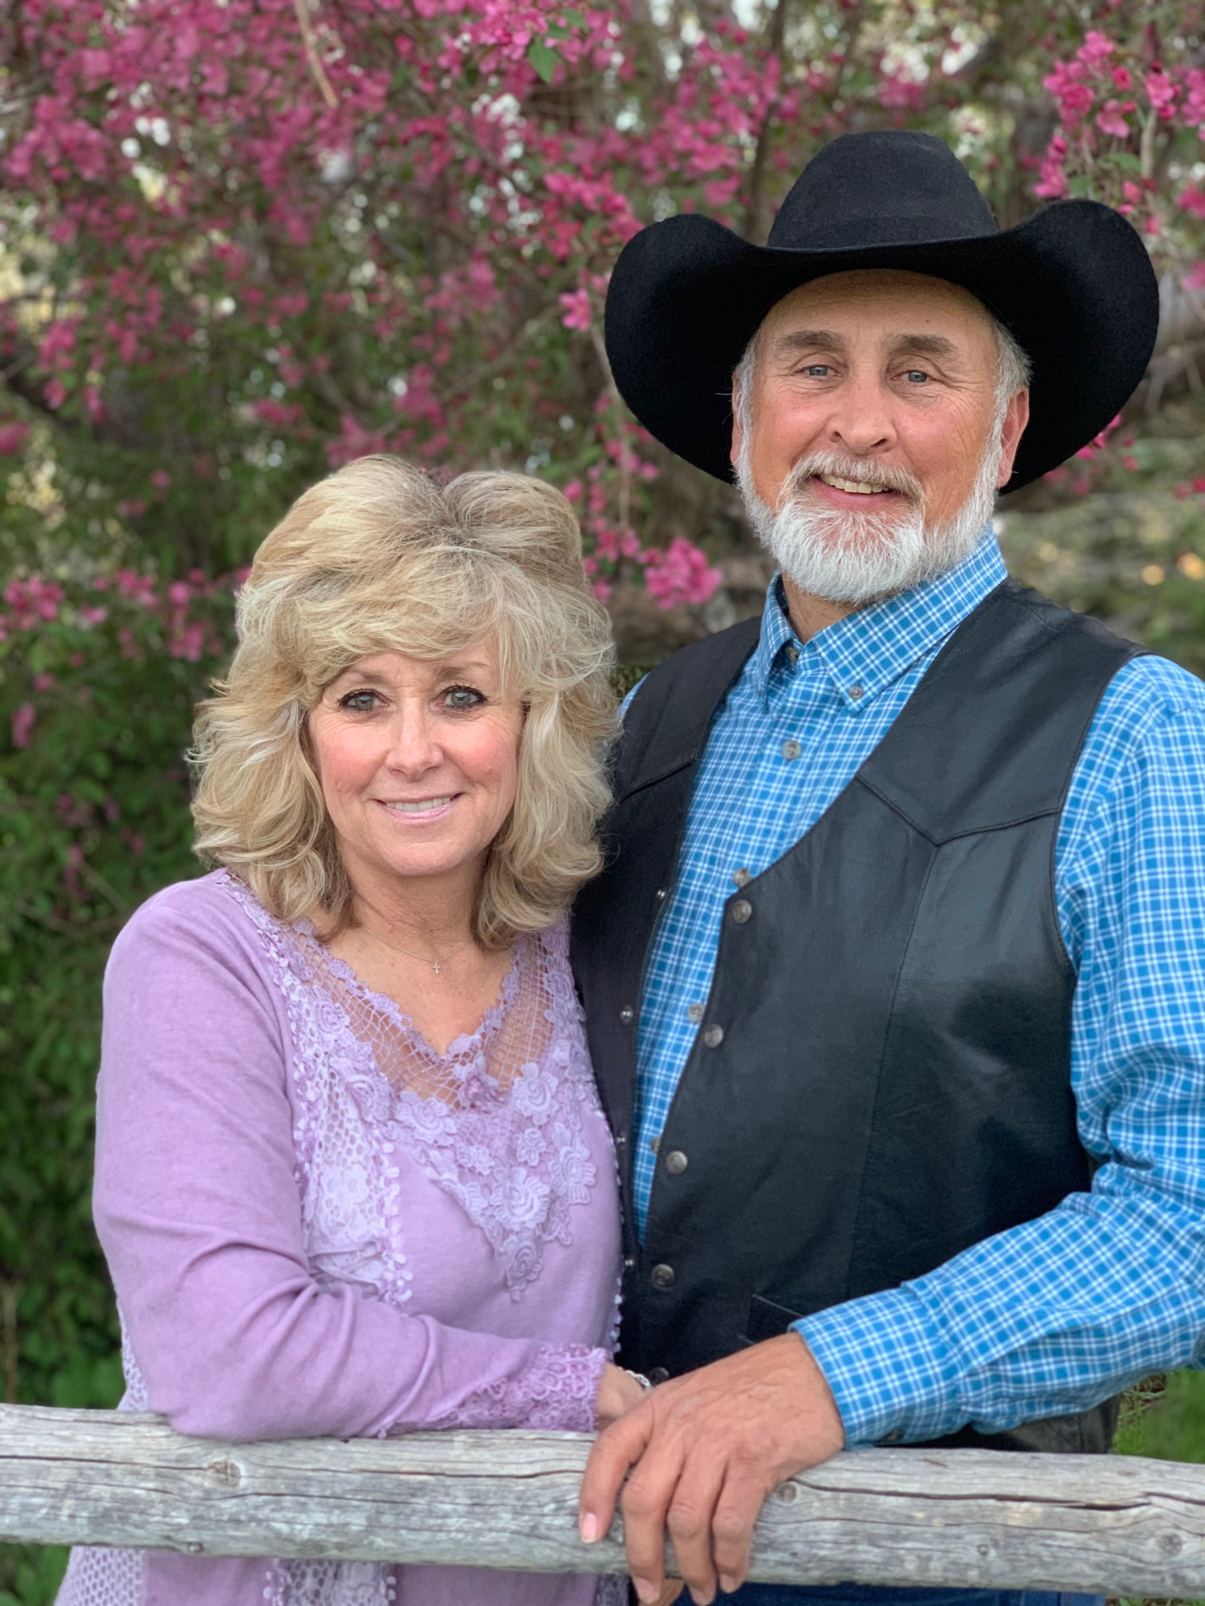SPOKANE, WASHINGTON – King Ranch Company LLP received the inaugural ***Chuck Jarecki Rancher Land Stewardship Award*** at the Society for Range Management’s 78th Annual Meeting in Spokane, Washington last month. The award was recently established thanks to a generous donation by its namesake, Montana rancher Chuck Jarecki, a Society for Range Management (SRM) life member. The award recognizes ranch operators who demonstrate outstanding rangeland stewardship and contribute to the ranching profession through local, state, and national service.

King Ranch Company is a multigenerational cow-calf and yearling operation dedicated to rangeland conservation and sustainable livestock production. Located near Cheyenne, Wyoming, the ranch holds a grazing permit on the Medicine Bow-Routt National Forest. Owner Mark Eisele, President of the Pole Mountain Grazing Association, has been a strong advocate for ranching interests, successfully defending water quality regulations in federal court. The ranch integrates multiple land uses, including a wind farm, oil and gas developments, and Cheyenne’s landfill and water treatment facility, while maintaining strong conservation practices.

For over 20 years, King Ranch Company has monitored vegetation, photo points, and grassland birds to guide land management. Their drought plan includes rotational grazing, pasture rest, targeted grazing for cheatgrass control, and habitat restoration. The ranch also supports wildlife conservation, setting aside land for youth and disabled hunters while promoting responsible stewardship.

King Ranch Company is a leader in agricultural advocacy. Mark Eisele serves as President of the National Cattlemen’s Beef Association and has held key roles in the Wyoming Stock Growers Association and Land Trust. Recognized with awards like the Leopold Conservation Award, the ranch sets a high standard for balancing agriculture with conservation.

For his tremendous contributions to the management of rangeland ecosystems, it is with great honor the Society of Range Management recognized King Ranch Company with the ***Chuck Jarecki Rancher Land Stewardship Award.***