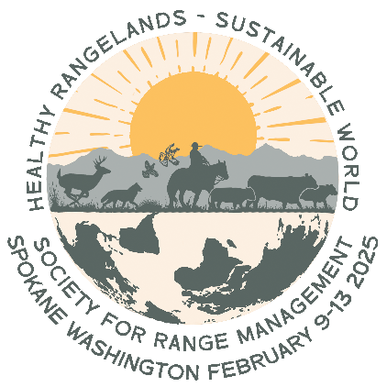
Call for Abstracts
SRM Annual Meeting Spokane 2025
Healthy Rangelands – Sustainable World

Click HERE to Submit
Abstracts DUE August 30, 2024

The 2025 SRM Annual Meeting is now accepting abstracts for Oral Presentations and Poster Presentations for our meeting to be held February 9-13, 2025.

Healthy Rangelands, Sustainable World is the theme of the 2025 Annual Meeting in Spokane. We invite your consideration of the concepts inherent in this theme as you prepare your presentations and posters for the meeting. Healthy Rangelands provide essential ecosystem services, recently summarized by SRM in the document, Rangeland Ecosystem Services: Connecting Nature and People, in which essential ecosystem services are characterized as food and fiber, water as an ecosystem driver in rangelands, carbon sequestration and security, plant, and insect biodiversity, and wildlife habitat provision. Sustainable World is one in which people will thrive well into the future. United Nations 17 Sustainable Development Goals characterizes a sustainable world as one promoting human prosperity while protecting the planet in terms of elimination of poverty and hunger, health, education, gender equality, clean and sanitary water, clean energy, decent work, and economic growth, infrastructure, (in)equality, cities and communities, consumption and production, terrestrial and aquatic life, peace and justice, and renewed partnerships for sustainable development. We encourage your thoughtfulness about Healthy Rangelands and Sustainable World while preparing your contribution to the 2025 meeting.

We invite you to submit a 300-word limit abstract by August 30, 2024, to present findings and foster discussion by these approaches:

- Oral Presentations will highlight research findings in 15-minute talks. Please plan on speaking for a full 15 minutes, with an additional 5 minutes allotted for Q&A, for a total of 20 minutes per speaker. All presenters are required to be in person. We will be accepting virtual submissions, but these will ONLY be posted online for viewing and will not be included in the Contributed Oral Session groupings.
- Poster Presentations provide a summary of findings that a viewer can read and understand in just a few minutes. We ask that all posters be presented in person, with maximum poster dimensions of 45” (w) by 48” (h) (smaller posters preferred). In-person posters may also be submitted in a digital file to be posted on the virtual meeting site. Digital files should be saved in either pdf or image format, allowing online viewers to zoom in and read information. Or, consider a story map, an online Prezi (audio/video recording) presentation, or a simple web page.

Each presentation will be assigned to a specific session on one day during the meeting. Authors will be expected to attend in person to present and answer questions during that period.

Review Criteria and Submission
Abstracts will be evaluated for relevance to rangeland ecology and management and potential interest to those attending the SRM meeting. Visit the Annual Meeting Website for more information. Submit your abstract by August 30, 2024. Abstracts must be 300 words or less (with no line or paragraph breaks, no bulleted lists), including the title, contact person, and project summary. Please keep in mind that your abstract title determines the “grouping” of your talk and/or poster; please word it accordingly. There is limited space for presentations and no guarantee that all abstracts will be accepted. Notification will be sent by September 30, 2024 regarding all submissions.

Click HERE to Submit

