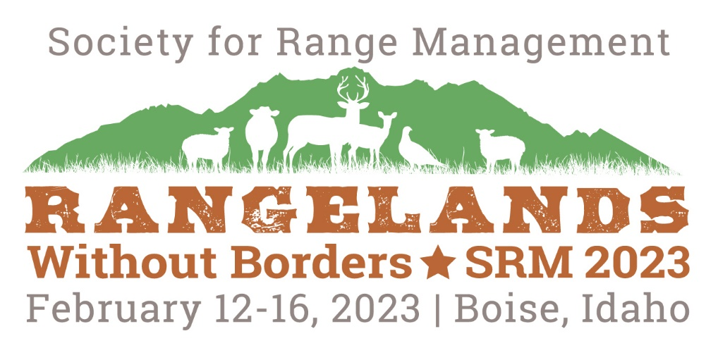
Session Description
Submit to: specialsessions@rangelands.org
- Session Title (Maximum 20 words)
- Corresponding contact
- Session Sponsors (if applicable). Sponsors can provide financial aide for attending speakers, dissemination of session material, or become a general sponsor for the general meeting.
- Description (This may be included in the meeting program) Maximum 100 words:
- Session Type (Symposium, Workshop, Ignite, Campfire, Practicum, etc.)
- List of Speakers (if applicable) and proposed titles for individual presentations.
- The virtual format of the 2023 Boise meeting will require 2 moderators per session; one is the traditional style of moderator (has to present in person, introduces speakers, controls timing, takes questions from the live audience, etc.). The additional moderator will manage the online delivery (start recording, manage online questions via the chat, be the liaison with the meeting technical director for any virtual challenges). Please indicate who the traditional moderator will be for your session and whether you can provide a dedicated virtual moderator as well. The virtual moderator will be required to participate in pre-session training.
- Justification. Please provide any additional information you deem important (use the review criteria in the Call for Proposals as a guide). Maximum 300 words.

