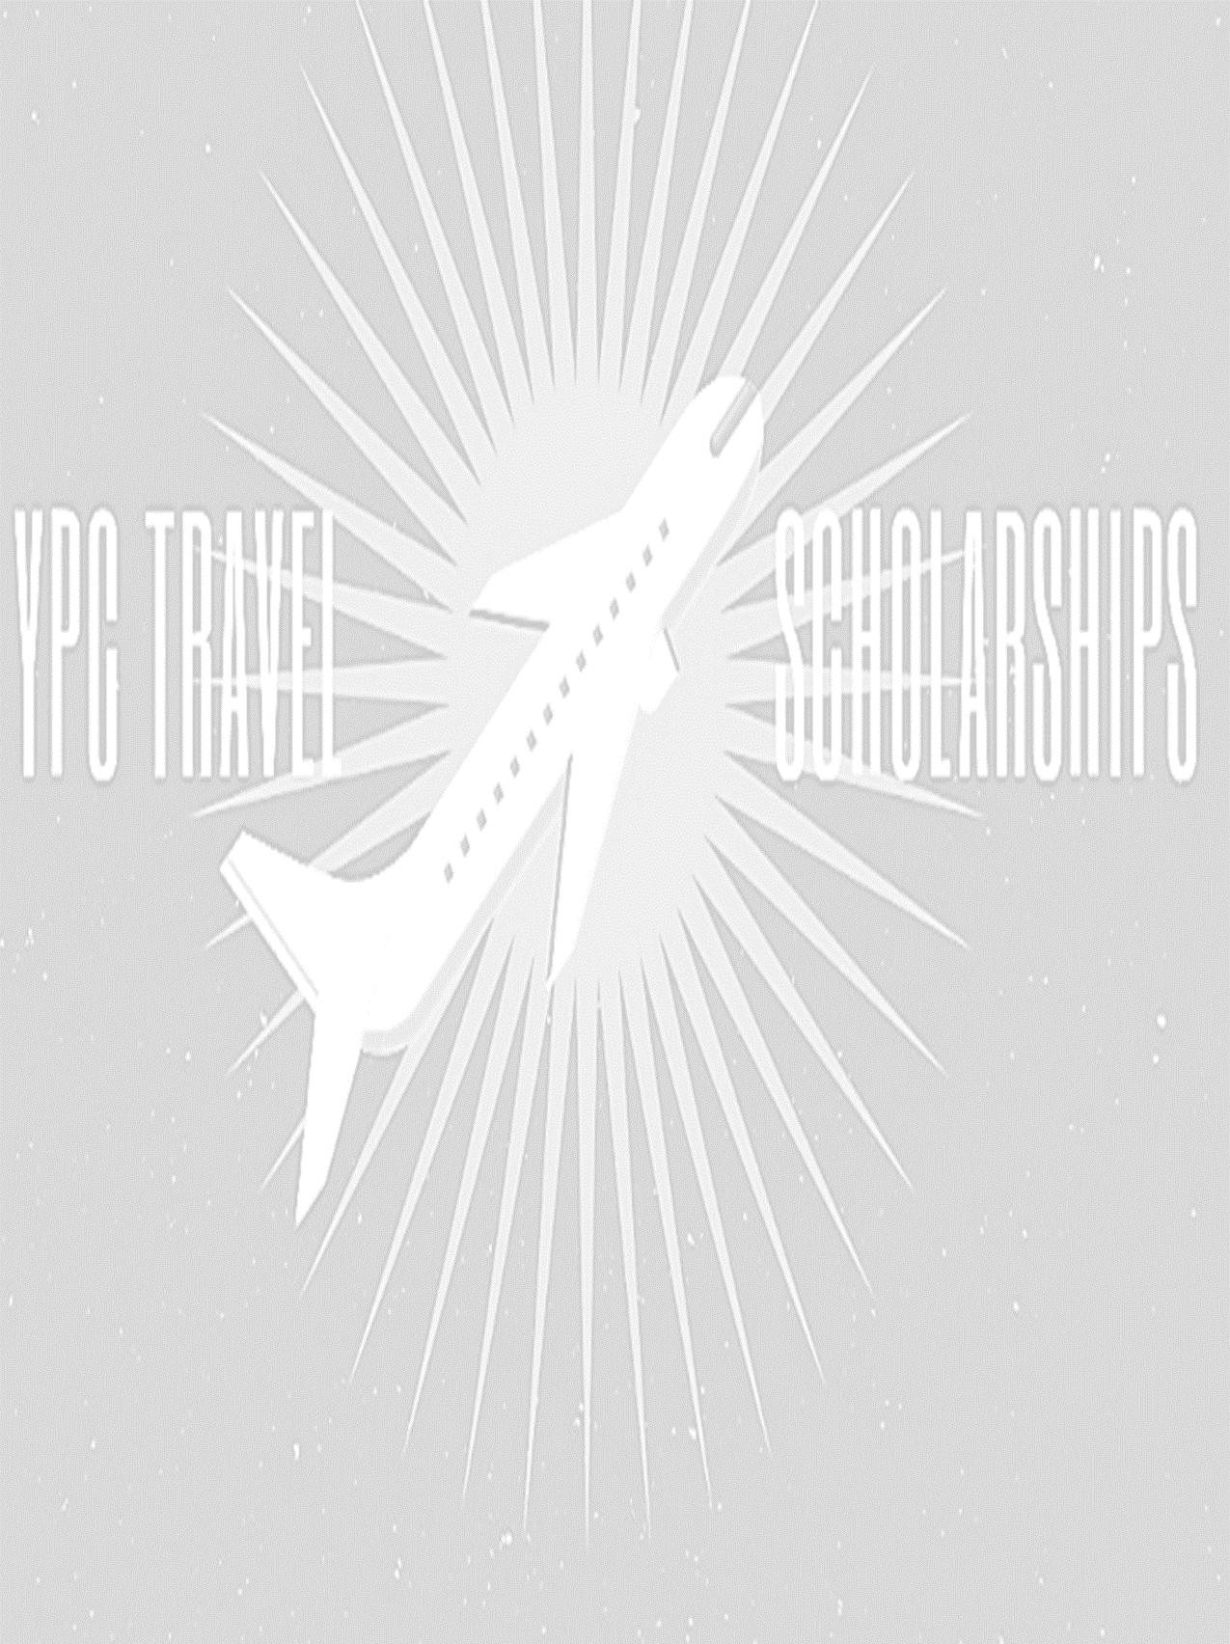

2020 Society for Range Management- Young Professionals Conclave Travel Scholarship
The Society for Range Management-Young Professionals Conclave (YPC) awards two (2) $500 travel scholarships to two outstanding young professionals active in range management to assist in paying for attendance at the national Society for Range Management (SRM) Annual Meeting. To qualify, the applicant must be a) currently employed in a range-related job, b) currently pursuing a graduate degree in range-related degree, or c) unemployed but recently graduated from a range-related degree or recently left a range-related position. There is no age limit to qualify for these scholarships; however, one must have been working in the range profession (excluding graduate degrees) for 5 years or less. Additionally, recipients of the scholarship must attend both the YPC social and business meeting held at the annual SRM meeting in order to receive the funding. Scholarships will be presented to the recipients after these requirements have been fulfilled at the awards ceremony during the annual meeting.
Selection will be based on achievement, leadership, financial need, and participation in range-related activities with preference given to SRM involvement. Though this scholarship is for new range professionals, the selection committee will still be looking for a commitment to range or natural resources. Financial need will play a large role in the selection of the travel scholarship recipients. The selection committee is looking for a candidate that is committed to range conservation, will participate and benefit the YPC with his or her involvement, will be a good representative of young professionals within the SRM, and someone who will be paying a significant portion of the trip out-of-pocket. You do not qualify if your employer or graduate advisor is covering the cost of your trip. This scholarship is intended to cover costs that would otherwise be paid out-of-pocket.
Applications are available on the YPC website http://rangelands.org/committees/young-professionals-conclave/ under the “YPC Travel Scholarship” tab. Applications must be completed and submitted with the following: application form, resume or CV, two letters of reference (preferably one from your employer) and a statement from your employer that they are not covering the cost of your travel (if they are partially funding the trip, please have them describe their financial contribution in detail). Letters of reference should be emailed directly to the scholarship committee chairperson from the writer of the letter or in sealed envelopes with signature over envelope seal if sent via post mail.
Please email all application materials to Veronica Urbanczyk at veroni2016@gmail.com by December 31, 2019. You will be notified the second full week in January if you are a scholarship recipient.

SOCIETY FOR RANGE MANAGEMENT
YOUNG PROFESSIONALS CONCLAVE
SCHOLARSHIP APPLICATION

Date _______________________
1. Name ____________________________________________
2. Mailing Address _____________________
3. Date of Birth ______________________________________________________
4. Length of time you have been working in the range field _____________________
Attach additional sheets of paper for the following questions as needed.

5. Describe how you think involvement in the YPC will help you.

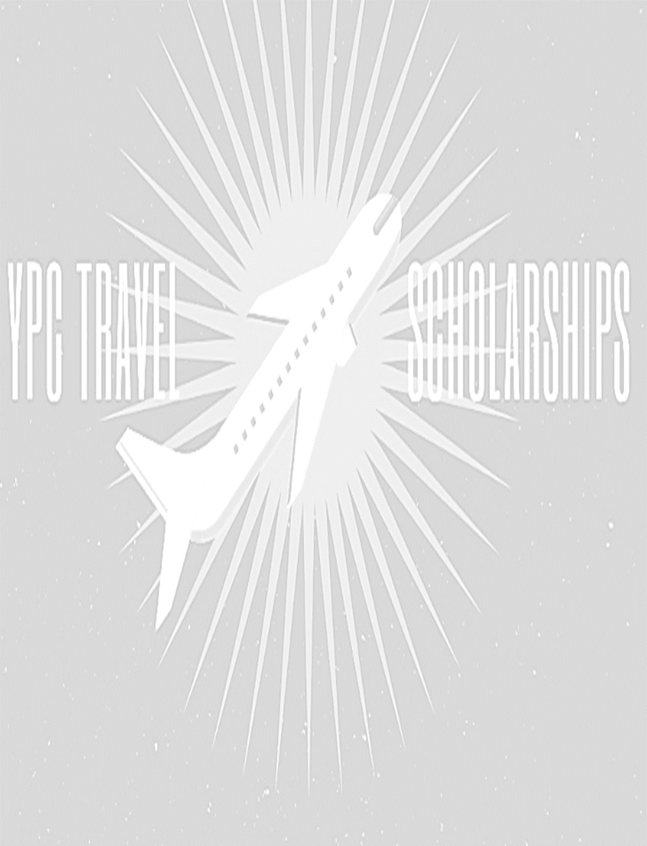
6. Describe how you will benefit the YPC as a group with your involvement.

7. Describe your career plans and why you believe a scholarship award would be justified in your case.

All application materials MUST BE RECEIVED BY December 31, 2019
E-MAIL TO: Veronica Urbanczyk
veroni2016@gmail.com

