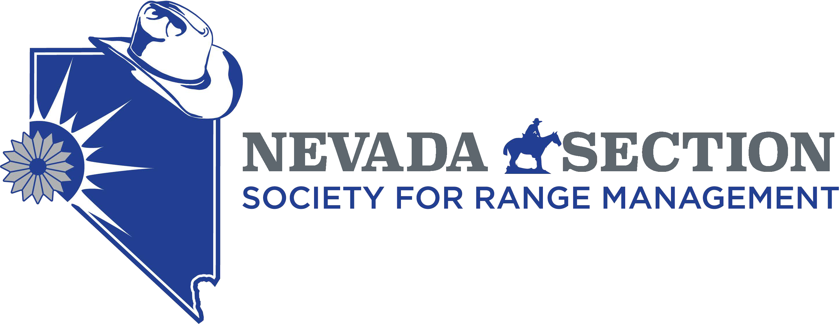 Living with Fire
Presented by the Nevada Section, Society for Range Management

REGISTRATION FORM
Thursday June 27th 2019
Winnemucca, NV
Field tour of the Martin Fire area

Registration 7:30am Paradise Valley Community Center (address?)

Producer Round Table 8am
Field tour 9am – 3pm
Friday June 28th 8am Business meeting Dial in- 1-800-363-3734 Passcode: 6201512​

Registration Options (#1 or #2 are recommended)

- Email registration form to Erica Freese at: ericafreese66@gmail.com by June 24 and bring payment with you to the meeting.
- Mail registration form with payment included to Erica Freese at: 3900 Warren Way, Reno, NV 89509 by June 24.
- Register and pay upon arrival. (This method is not recommended due to meal planning difficulties).
Payment Options
Cash or check (payable to “NV SRM”). Credit card (bring to meeting) or PayPal (email Erica to be invoiced) can be used with a $3 per person fee. State employees can also utilize direct payment as NVSRM is a vendor.

Name: _________________________________________ Email: ___________________________________________
Name: _________________________________________ Phone: ___________________________________________
Check here for a receipt: ____

Check here if you need a vegetarian lunch(s): ____ How many? ______

Tour Registration Fees
SRM members
Non-SRM members
Students and Producers

Dinner

(#) x $50 = (#) x $70 =
(#)______x $20 = __________

(#) x $30 =

Credit Card Service Fee: $3.00 if paying with credit card $
Optional: Donation to 50-year member awards $

Total $ __________
CEU info?
If you have questions or concerns please contact Dave Voth nvsrmofficer@gmail.com or Erica Freese 775-530-3311.

