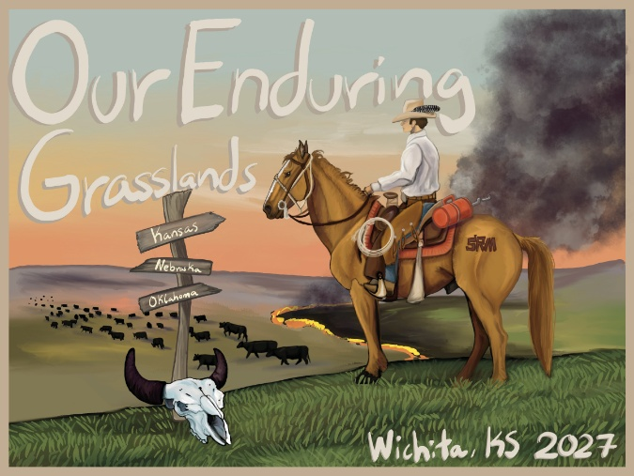
Session Submission Form
Submit to: specialsessions@rangelands.org
**All sessions must be submitted by July 17, 2026 for consideration.**

- Session Title (Maximum 20 words):

- Session Contact (must include Name and Email):

- Session Sponsors (if applicable). Sponsors can provide financial aide for attending speakers, dissemination of session material, or become a general sponsor for the general meeting.
- Description (This will be included in the meeting program) Maximum 100 words:

- Session Type (Symposium, Workshop, Ignite, Campfire)

- Requested Length of Session (this cannot be guaranteed, but will be taken into consideration); the 2027 program is set-up to provide for 1 hour 40 minute time blocks; 3-session blocks each day (10:20am-noon; 1:20pm-3pm; 3:20pm-5pm); please indicate if “one” time block is needed, or multiple (ie: half day or full day session):

- Target Audience: Who is your session geared toward? (Producers, Young Professionals, Federal Agency employees, etc.):

- Expected Room/Audience size: While we know it is difficult to predict session attendance; please indicate here your best estimate for your room size needs: Large room (150+); Medium room (100); small room (50); the planning committee will do our best to plan for all space needs and requests:

- Proposed/Draft list of Speakers (if applicable) and titles for individual presentations. Final session agendas, including speaker names, time slots and presentation titles, must be submitted by September 11, 2026 (a template to submit this information will be provided once your session is confirmed).

- Requested Room Set-Up (this cannot be guaranteed, but will be taken into consideration, options are: theater or workshop/classroom seating (round tables are not available)); all rooms will be set Theater style, unless otherwise communicated:

- AV & Technical: Select sessions will be live-streamed and recorded at the 2027 meeting; not all sessions will be set-up for this function. This capacity will be determined by the planning committee and communicated to organizers upon acceptance. At that time, we will ask you to finalize any moderators needed.
Symposia sessions will be live-streamed and recorded at the 2027 meeting. If you DO NOT wish to have your session live-streamed and recorded, please indicate that below.
Workshops and Ignite: Organizers must request to be live streamed; otherwise, workshops and ignite sessions will not be set-up to do so. Please indicate below.
Campfire sessions will not be live streamed.

Please indicate your AV preference here:

- Justification. Please provide any additional information you deem important (use the review criteria in the Call for Proposals as a guide). Maximum 300 words.

